Github Link: <https://github.com/jotishkumar/SQL-Portfolio-Project>

Medium Link: <https://medium.com/@jotishkumar950/understanding-customer-churn-a-sql-analysis-of-the-customer-churn-dataset-69a0e7581ac5>

**Query 1: Considering the top 5 groups with the highest average monthly charges among churned customers, how can personalized offers be tailored based on age, gender, and contract type to potentially improve customer retention rates?**

**Answer:**

create database project;

select * from customer_churn_dataset;

ALTER TABLE customer_churn_dataset

CHANGE `Monthly Charge` `Monthly_Charge` double;

ALTER TABLE customer_churn_dataset

CHANGE `Churn Label` `Churn_Label` text;

SELECT

Customer_ID, Age,

Gender,

Contract,

AVG(Monthly_Charge) AS Avg_Monthly_Charge

FROM

customer_churn_dataset

WHERE

Customer_Status = 'Churned'

GROUP BY

Customer_ID, Age, Gender, Contract

ORDER BY

Avg_Monthly_Charge DESC

LIMIT 5;

**SnapShot:**

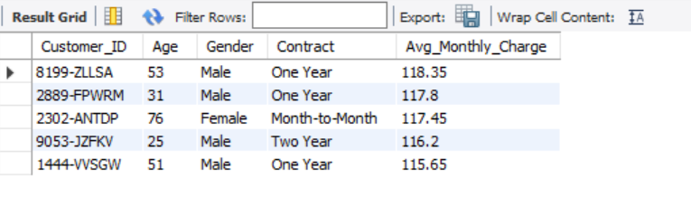

**Explanation:**

The first two queries alter the customer_churn_dataset by renaming the following columns to improve clarity and usability:

Monthly Charge is changed to Monthly_Charge ;

Customer Status` is changed to Customer_Status;

The third query analyzes the dataset to find out how much churned customers typically paid each month. It looks at the average monthly charge for these customers, grouped by their age, gender, and contract type. The results are sorted from the highest to lowest average charge, showing the top 5 groups with the highest average monthly payments.

**Query 2: What are the feedback or complaints from those churned customers**

**Answer:**

ALTER TABLE customer_churn_dataset

CHANGE `Customer ID` `Customer_ID` TEXT;

ALTER TABLE customer_churn_dataset

CHANGE `Churn Reason` `Churn_Reason` TEXT;

ALTER TABLE customer_churn_dataset

CHANGE `Satisfaction Score` `Satisfaction_Score` TEXT;

ALTER TABLE customer_churn_dataset

CHANGE `Churn Category` `Churn_Category` TEXT;

SELECT

Customer_ID,

Churn_Reason,

Satisfaction_Score,

Churn_Category

FROM

customer_churn_dataset

WHERE

Customer_Status = Churned;

Snapshot:

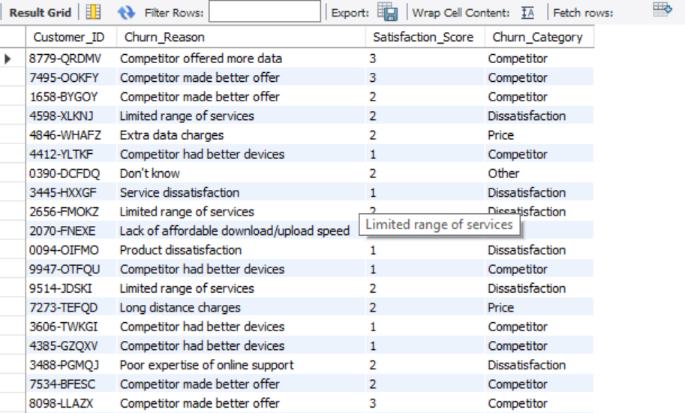

**Explanation:**

The first four queries alter the customer_churn_dataset by renaming the following columns to improve clarity and usability:

1. Customer ID is changed to Customer_ID.
2. Churn Reason is changed to Churn_Reason.
3. Satisfaction Score is changed to Satisfaction_Score.
4. Churn Category is changed to Churn_Category.

The last query selects the Customer_ID, Churn_Reason, Satisfaction_Score, and Churn_Category specifically for customers who have churned, indicated by Customers_Status = 'Yes'. This query is intended to facilitate analysis of customer feedback and satisfaction at the time of their departure.

**Query 3: How does the payment method influence churn behavior?**

**Answer:**

ALTER TABLE customer_churn_dataset

CHANGE `Churn Score` `Churn_Score` int;

SELECT

`Payment Method`,

COUNT(CASE WHEN `Customer_Status` = 'Churned' THEN 1 END) AS Churned_Customers,

AVG(Satisfaction_Score) AS Average_Satisfaction_Score,

AVG(Churn_Score) AS Average_Churn_Score

FROM

customer_churn_dataset

GROUP BY

`Payment Method`

ORDER BY

Churned_Customers DESC;

**SnapShot:**

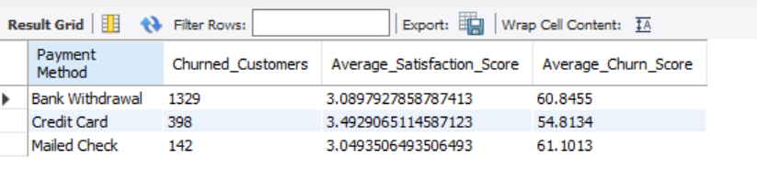

**Explanation:**

The first query modifies the customer_churn_dataset by renaming the column

1. Churn Score is changed to Churn_Score.

The second query retrieves information grouped by Payment Method, including the count of customers who have churned indicated by Customers_Status = 'Yes’, labeled as Churned_Customers. It also calculates the average satisfaction score of all customers as Average_Satisfaction_Score and the average churn score as Average_Churn_Score.

The results are ordered by the number of churned customers in descending order, facilitating an analysis of churn behavior in relation to different payment methods.